Affinity analysis in tableau: It tells you what people have in their basket alongside their product. What is says is for example when people buy papers they also buy binders 42 percent of the time. This has huge implication in jacking up sales or training your clerks like they can suggest hey if you are buying papers you can also buy the binders.

In the case below it is done along Sub Category but it can be done along product level.

Steps

Crate a level of detail calculation at category level so it will not be affected so this will not be affected by the filters applied and will always remain the same.

Create the following calculated fields

1: {fixed [Sub-Category]: sum([Number of Records])}

Drag Sub-the rows and calculated field 1 to the columns self and number of records to its right.

Click on dual axis on the number of records and synchronize it and sort the sub-category in the rows shelf in descending order based on the number of records.

Instead of keeping the same we can stack them so check on dual axis and synchronize the axis.

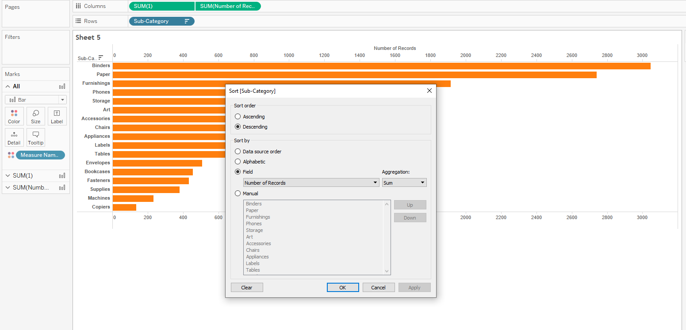

Create a subcat with the following settings

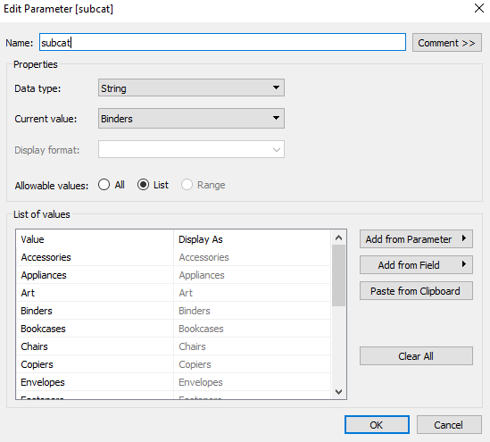.

Create a set on order Id as order id is the mechanism to match what’s in your market basket. The condition being if my Sub-Category equals my Sub-Category parameter then 1 else 0 and as we want to find the max of this to see if the order id has the same exact value that links up.

Ordercontainsparam with the condition

**max(iif([Sub-Category]=[subcat], 1,0))=1**

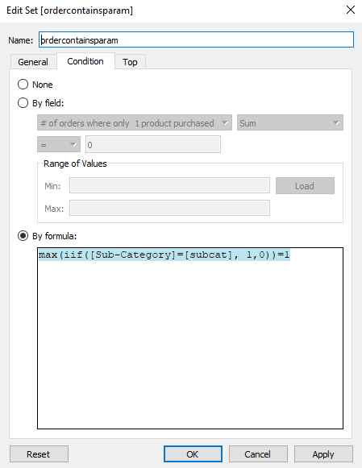

Click on show parameter control for the Sub-Category Parameter.

Drag the set created on filters

Create the following calculated fields

**highlight all**

**'all'**

**# of Orders of subcat**

if index()<> 1 then lookup(countd([Order ID]),-(index()-1)) END

**# of orders where only 1 product purchased**

if {include [Order ID]:countd([Product ID])}>1 then 1 end

**% of time purchased with any other product**

(countd([Order ID])-sum([# of orders where only 1 product purchased]))/countd([Order ID])

**Orders w subcat**

COUNTD([Order ID])

Drag the following calculated field to the tooltip for detailed analysis.